AWS S3 and Cloud Security

Name: Poorna Chandra Dinesh

Course Title: Cloud Administration and Digital Workspaces

Clarku mail: [pdinesh@clarku.edu](mailto:pdinesh@clarku.edu)

# Step 1 – IAM Users and Groups

## Two **groups**:

Successfully created two IAM groups named **Editors** and **Readers** to organize users according to their access levels and roles.

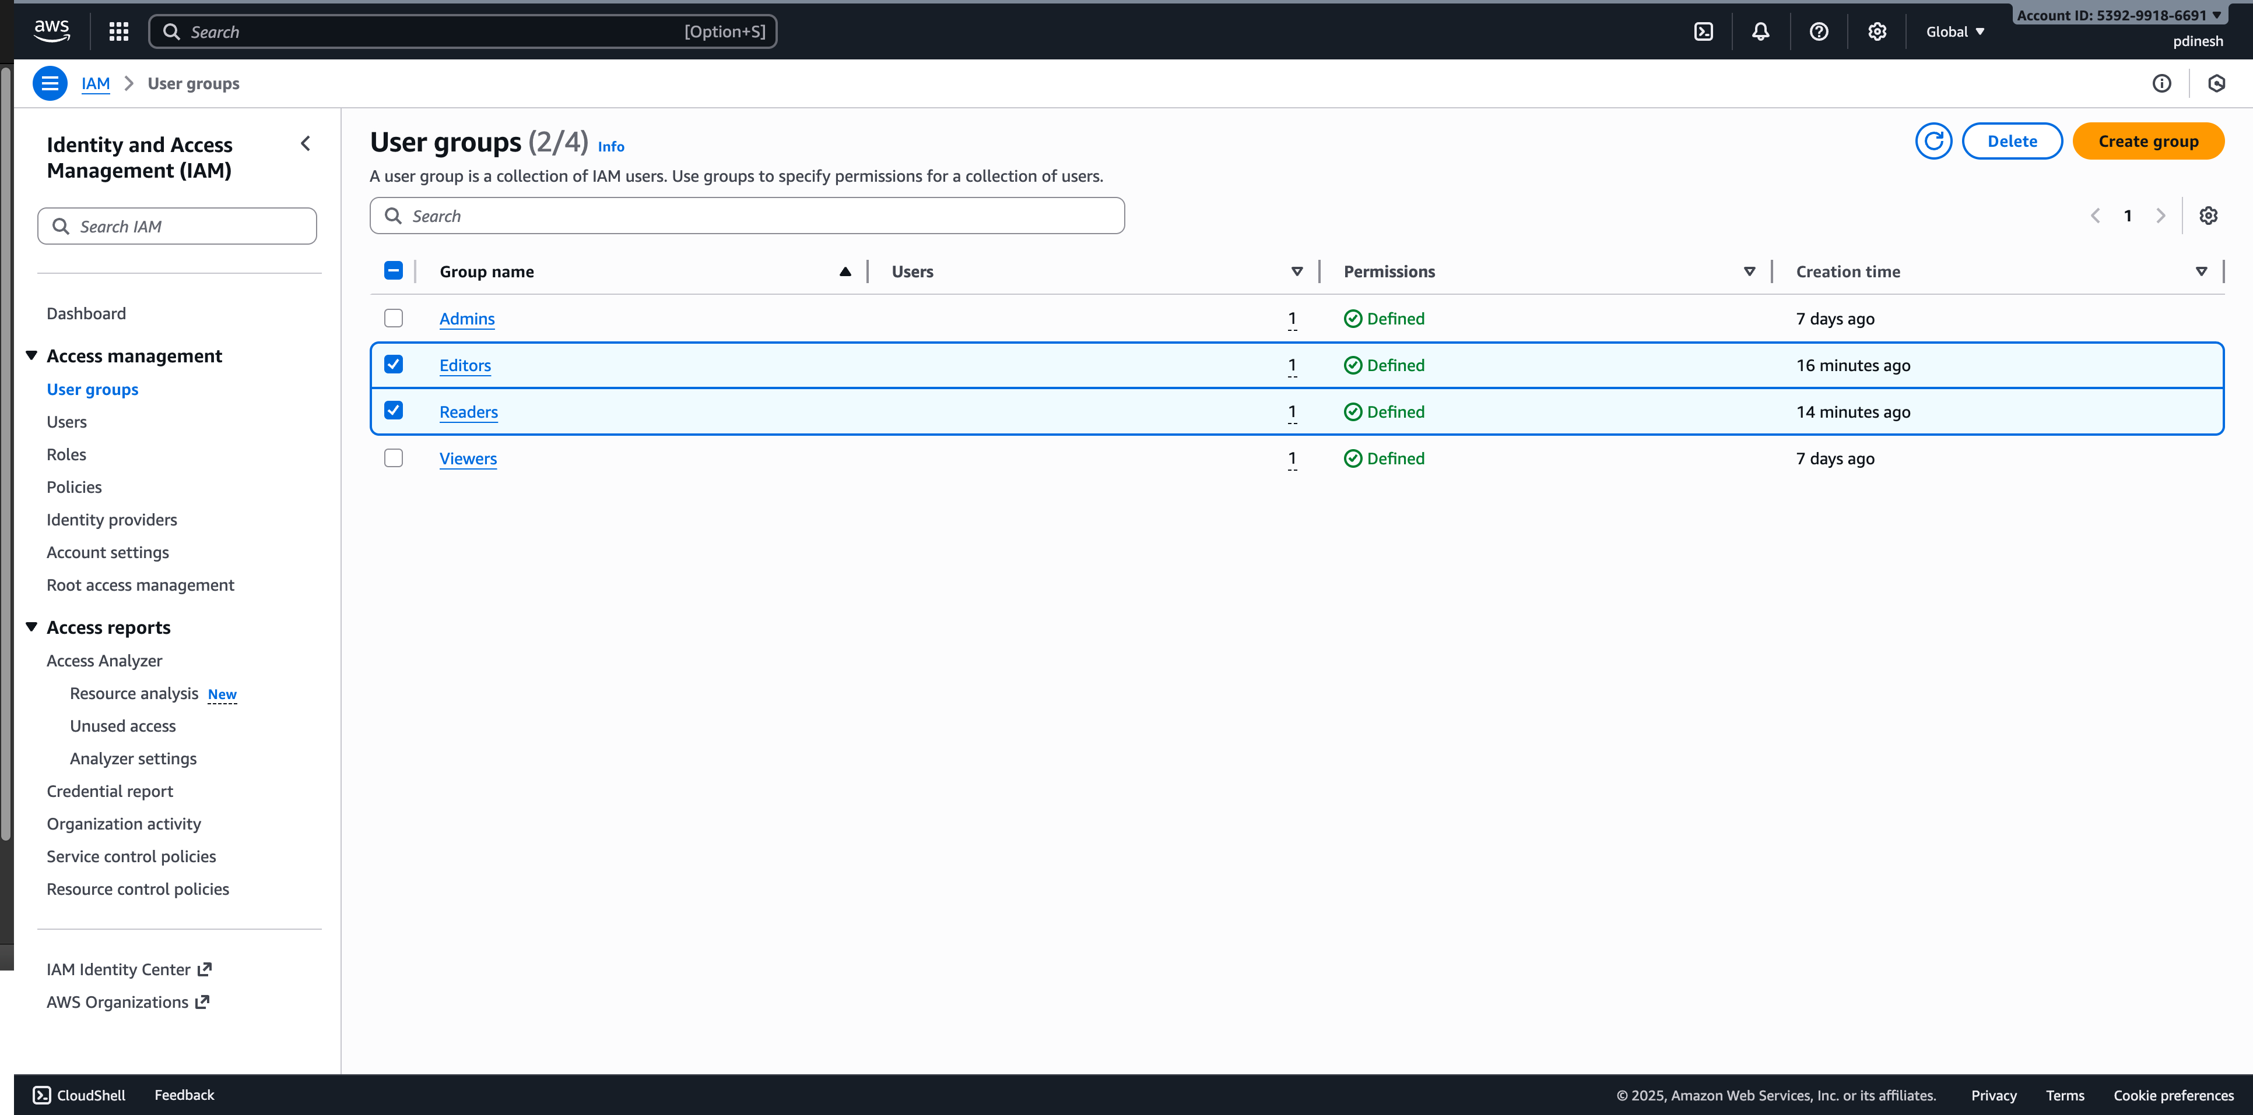

## Two **users**:

Successfully created two IAM users, **user-editor** and **user-reader**, to represent the personnel who will access AWS resources with different permissions.

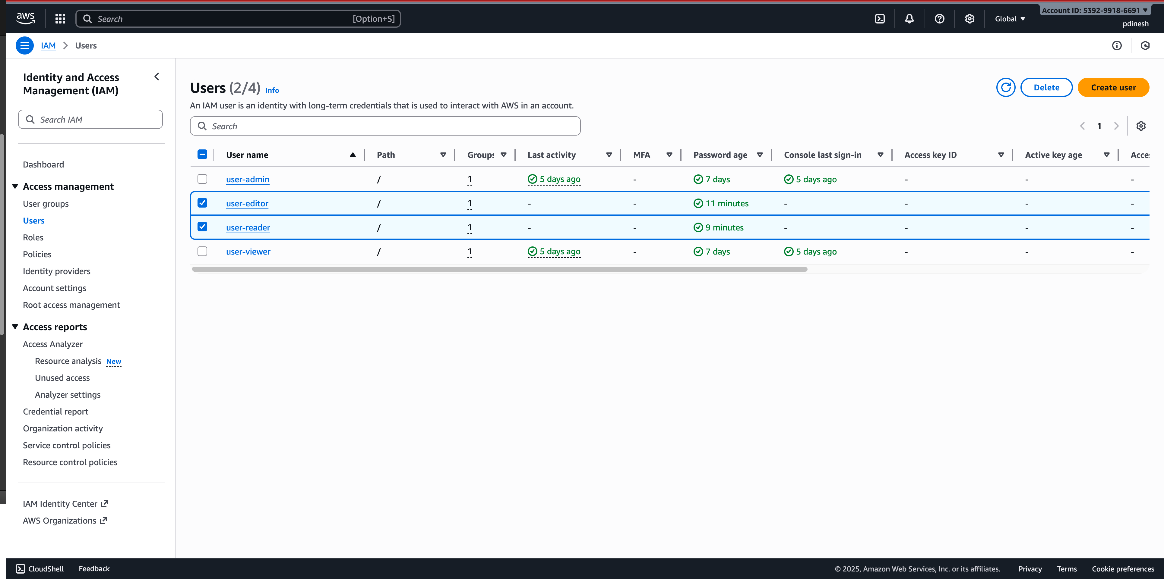

## User Group Assignment:

Successfully added **user-editor** to the **Editors** group and **user-reader** to the **Readers** group, ensuring that each user inherits the permissions assigned to their respective groups.

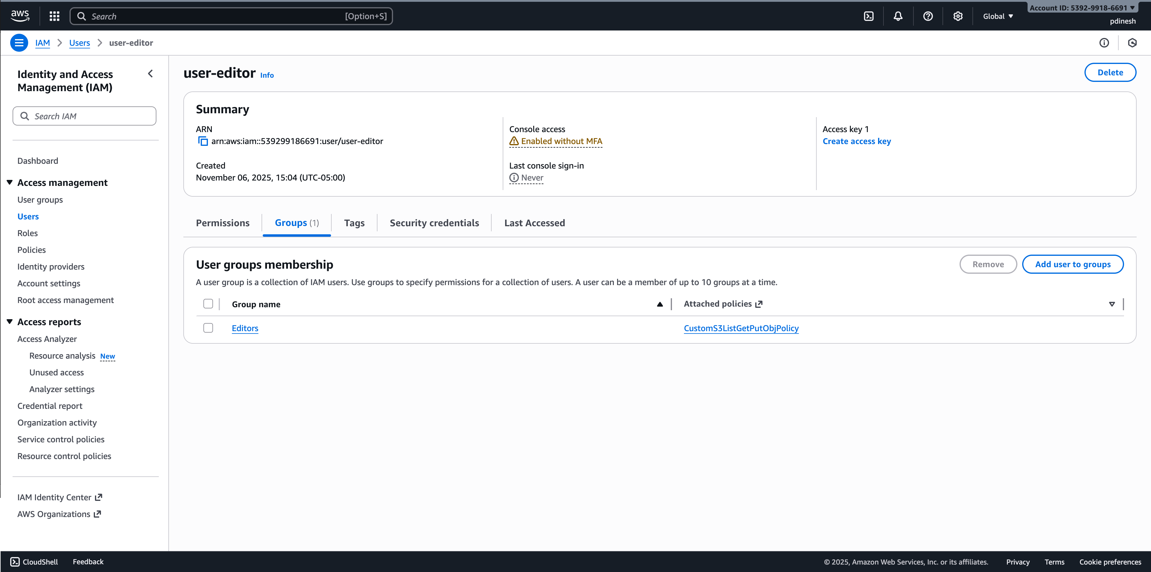

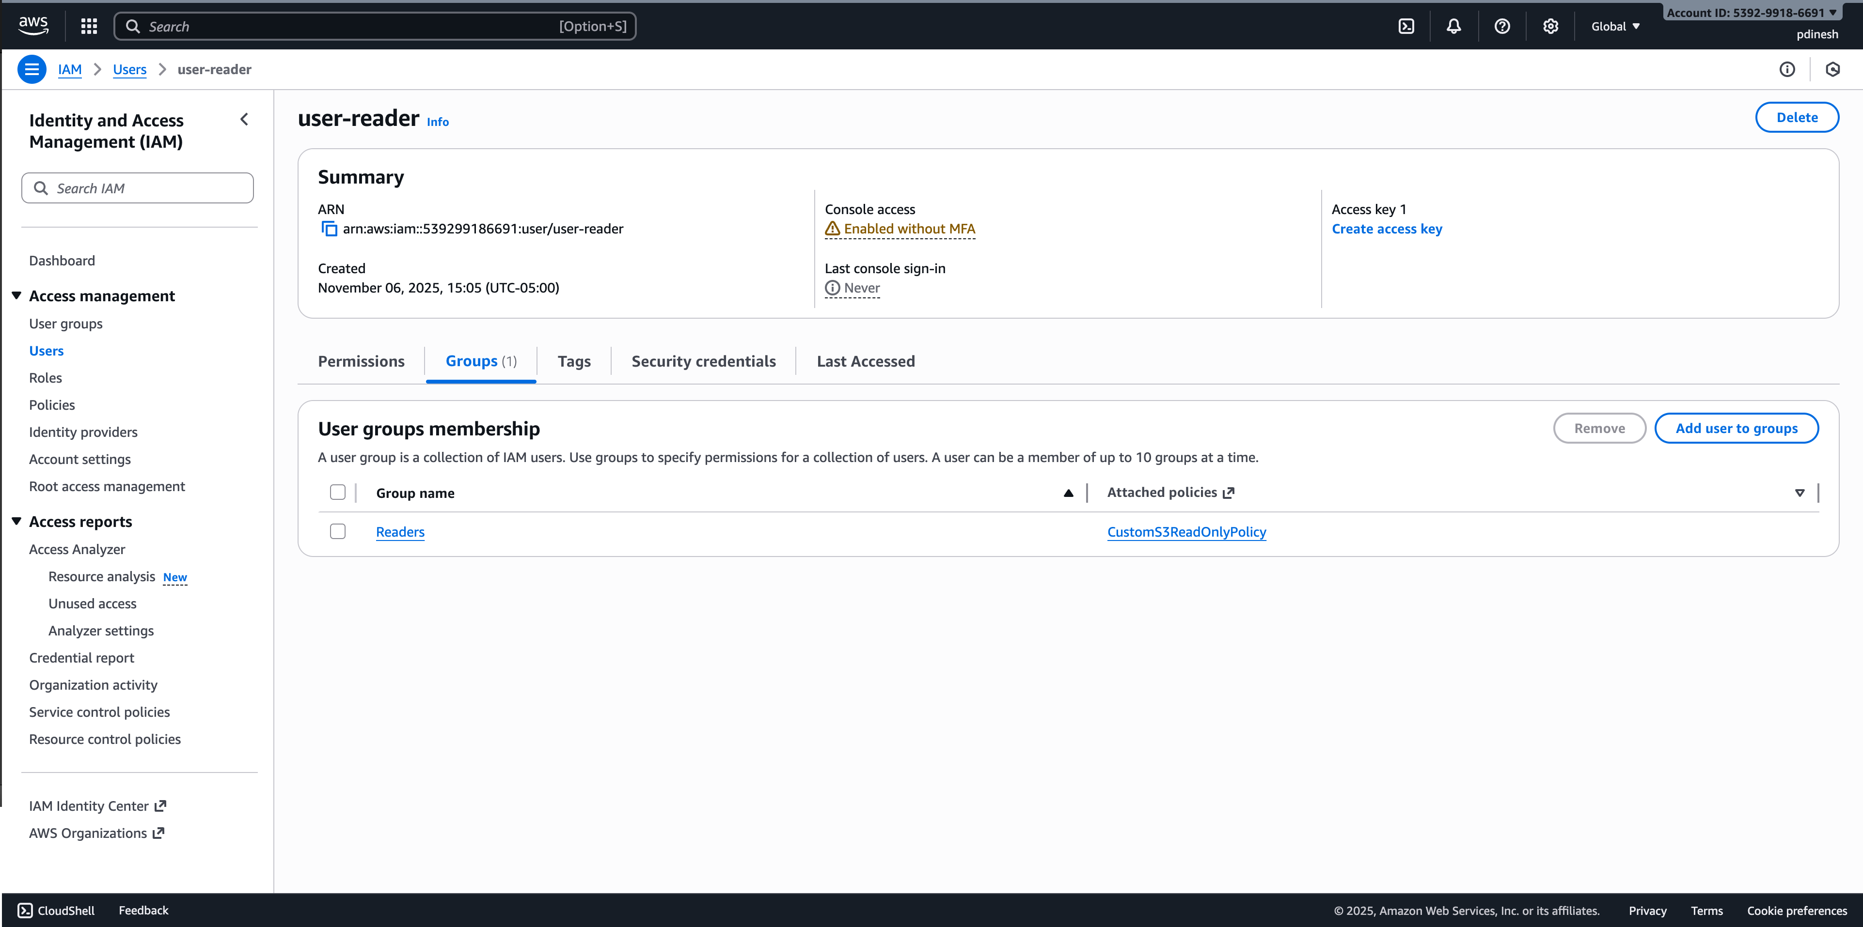

## **Permissions custom IAM policy** **Editors:**

Successfully created a **custom IAM policy** for the **Editors** group that allows listing all S3 buckets (s3:ListBucket), reading and writing objects in S3 (s3:GetObject, s3:PutObject), and connecting to EC2 instances using Session Manager or SSH, and attached this policy to the **Editors** group.

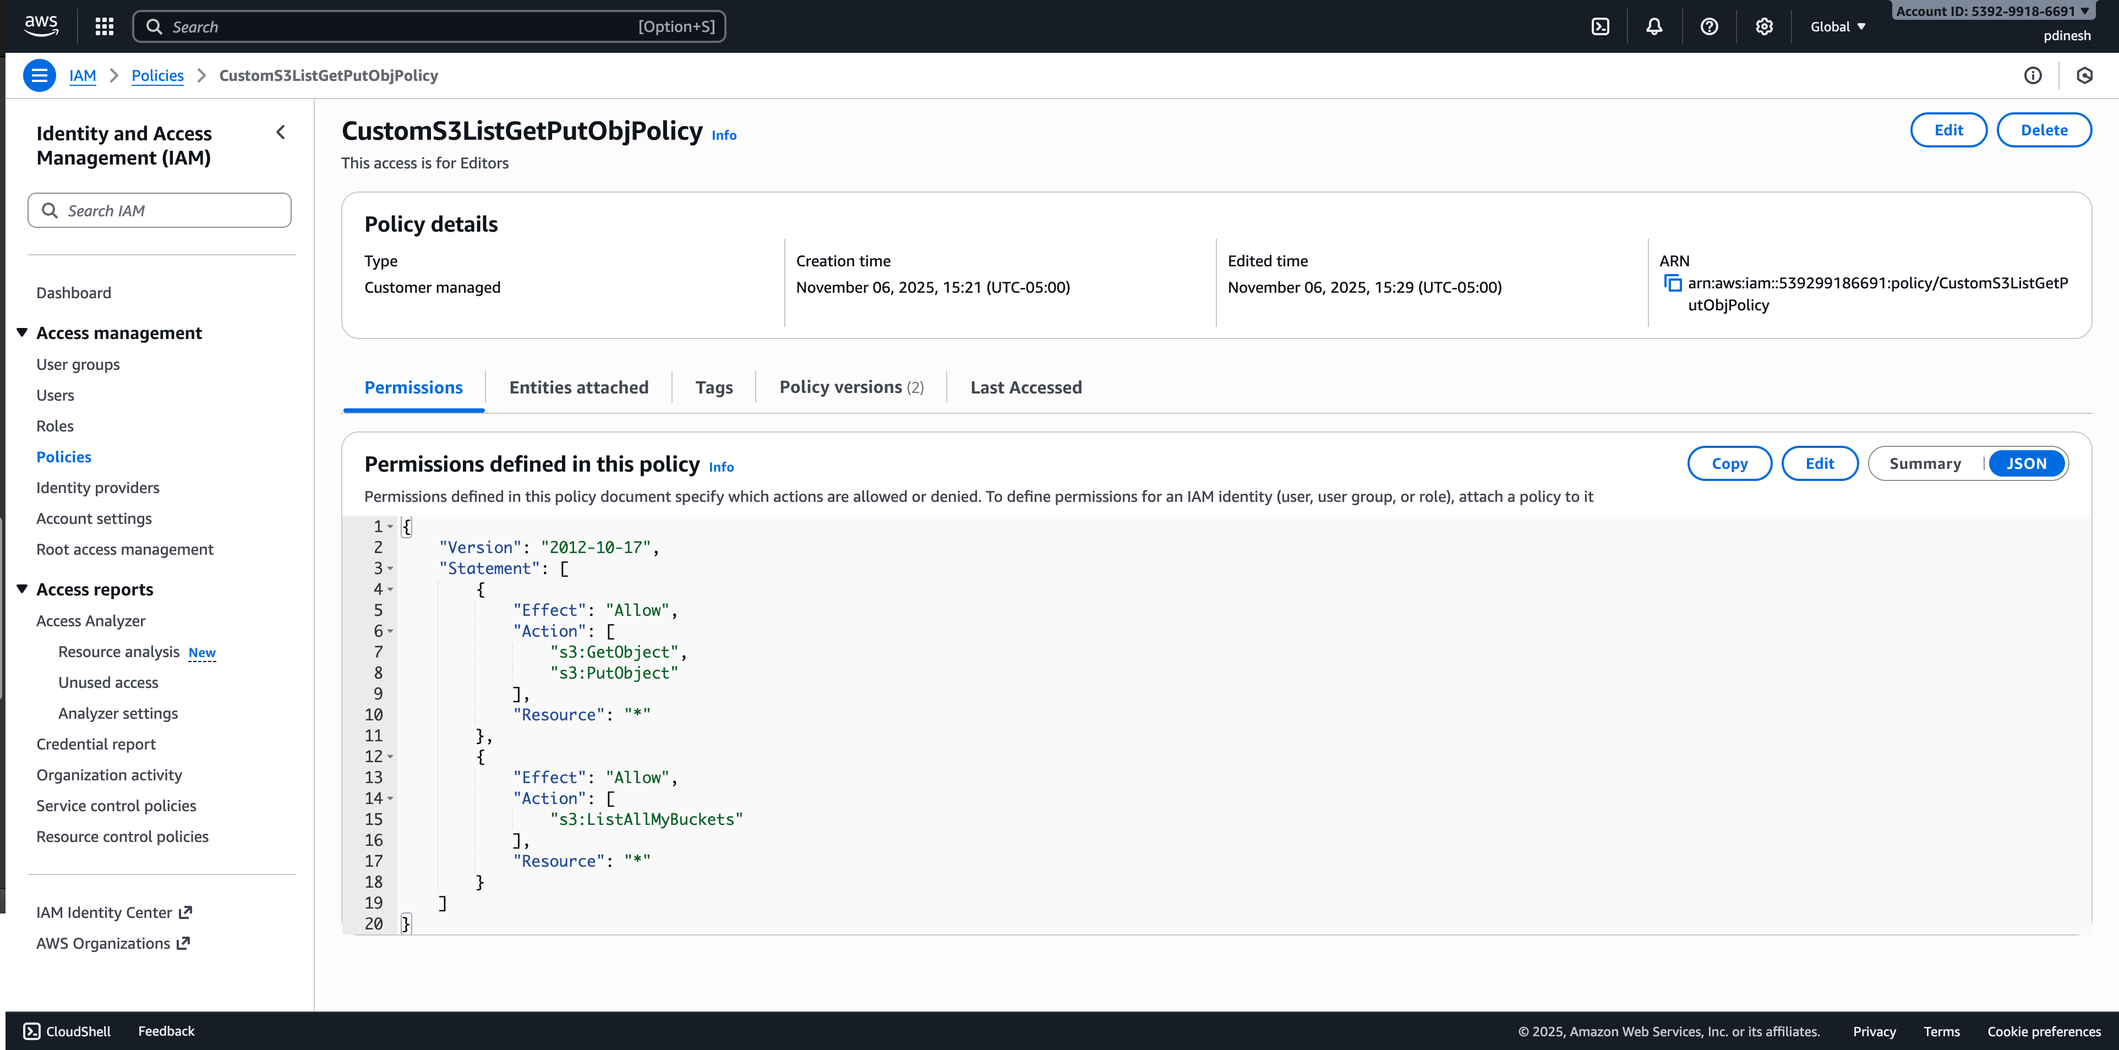

## **Permissions custom IAM policy** **Readers:**

Successfully created a **custom IAM policy** for the **Readers** group that allows listing all S3 buckets (s3:ListBucket) and reading objects in S3 (s3:GetObject) only, and attached this policy to the **Readers** group.

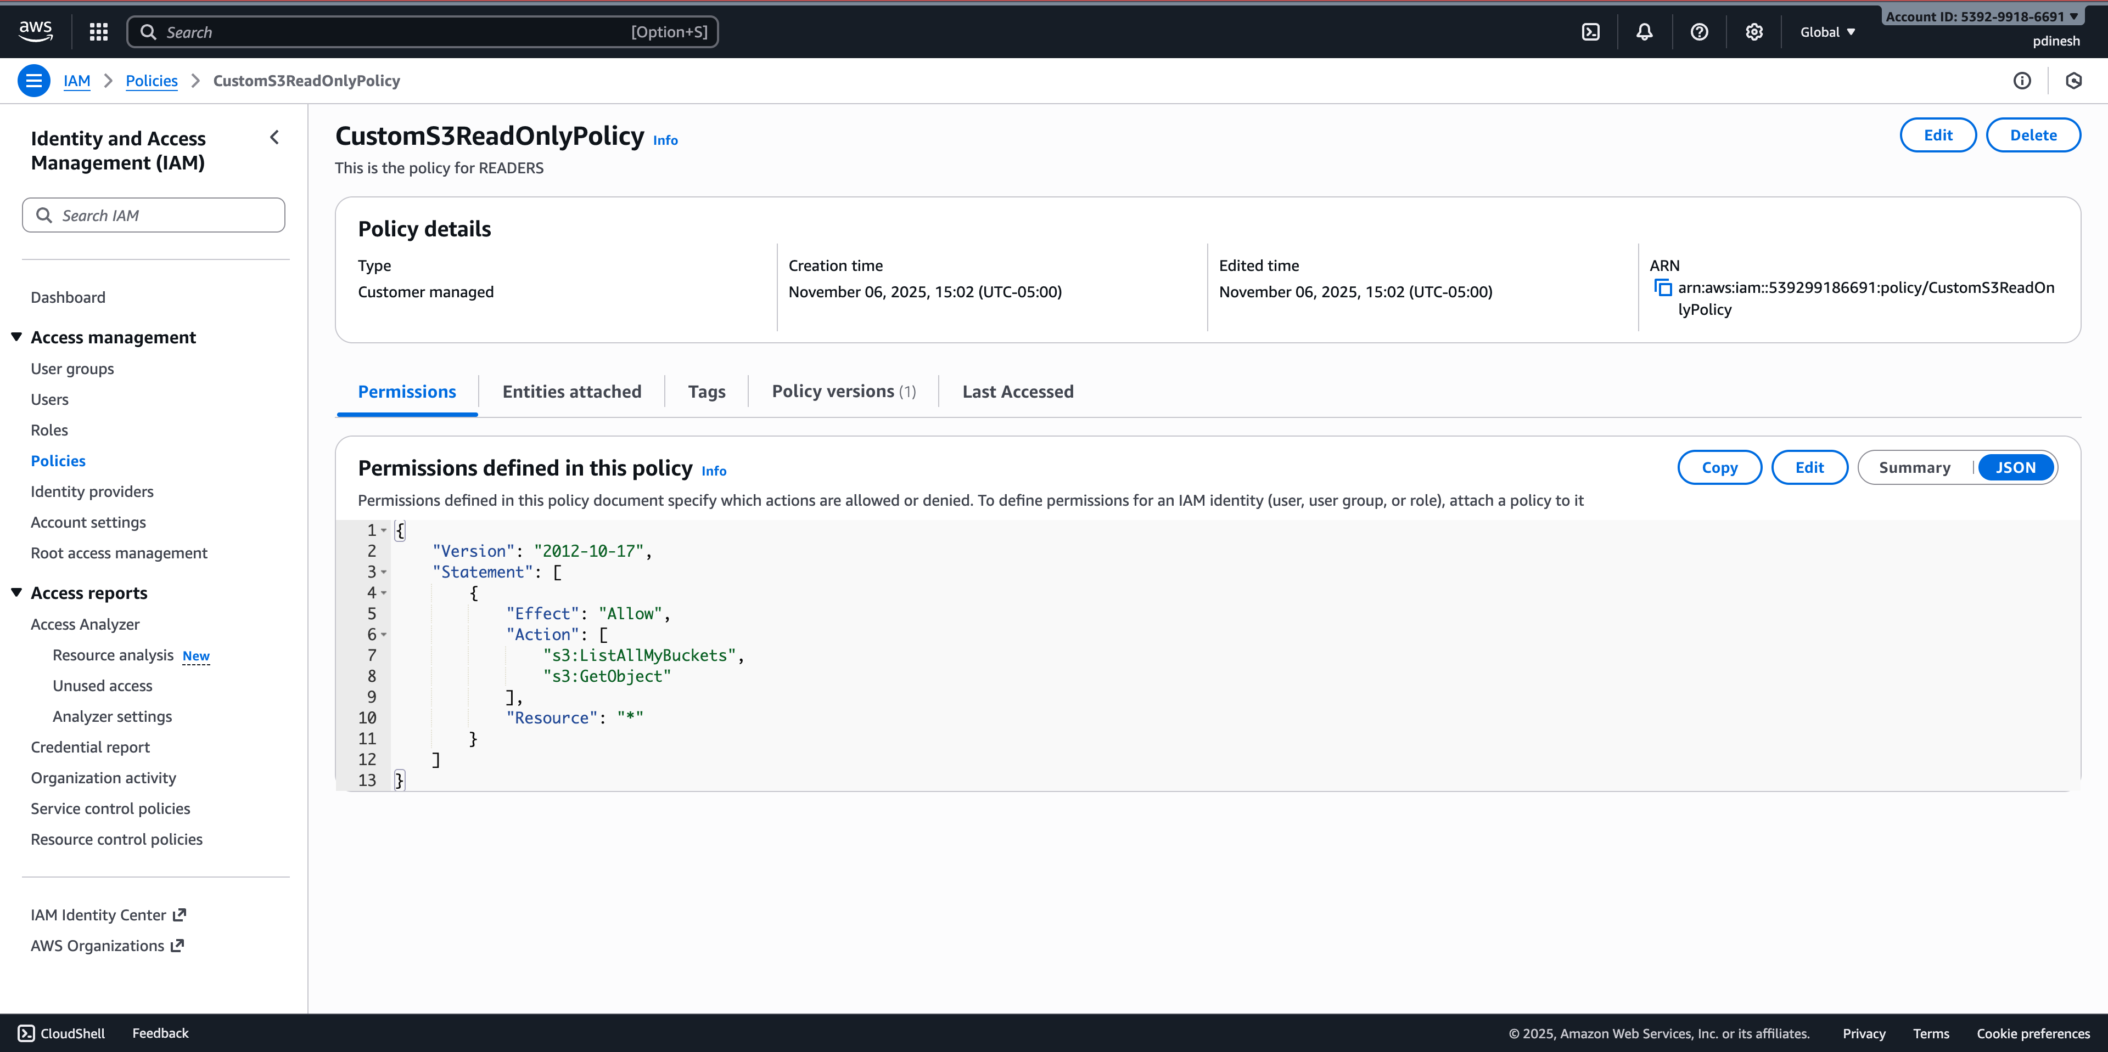

# Step 2 – Create an S3 Bucket

Successfully created an S3 bucket named **poorna-security-demo-bucket** in the AWS S3 console with the **“Block all public access”** setting enabled to ensure the bucket remains private and secure, uploaded a small text file Test1Upload.txt from the local computer to the bucket, and verified that the file appears in the bucket’s object list, confirming that the upload was successful and the file is accessible within the bucket.

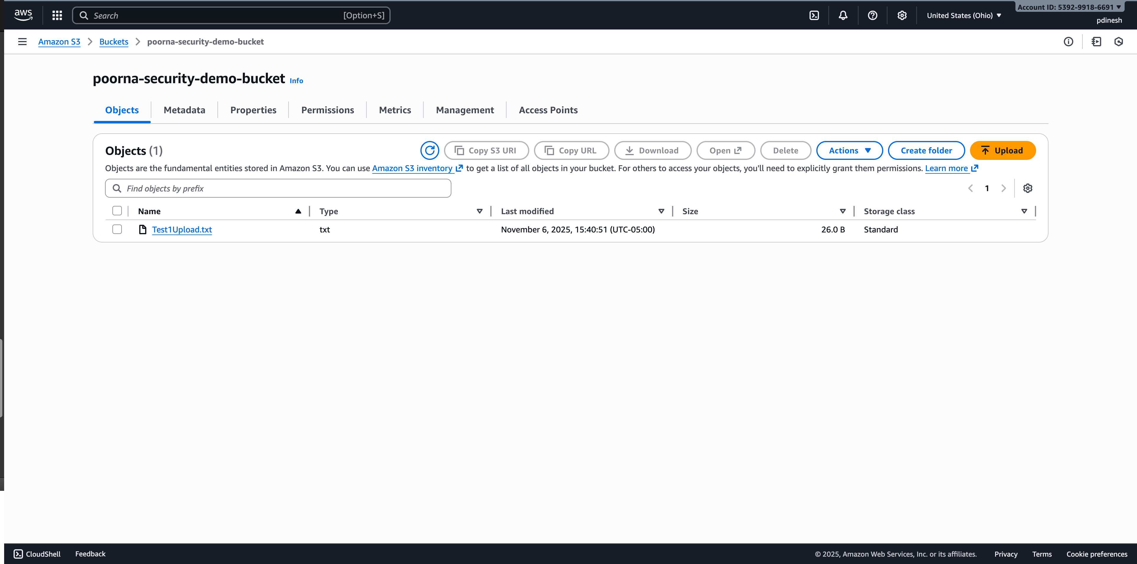

# **Step 3 – Create and Configure CloudTrail**

Created CloudTrail trail **poorna-demo-trail**, applied to all regions, with a new S3 bucket for log storage, Management events (Read/Write) enabled, and verified **Logging: ON** in the Trails list.

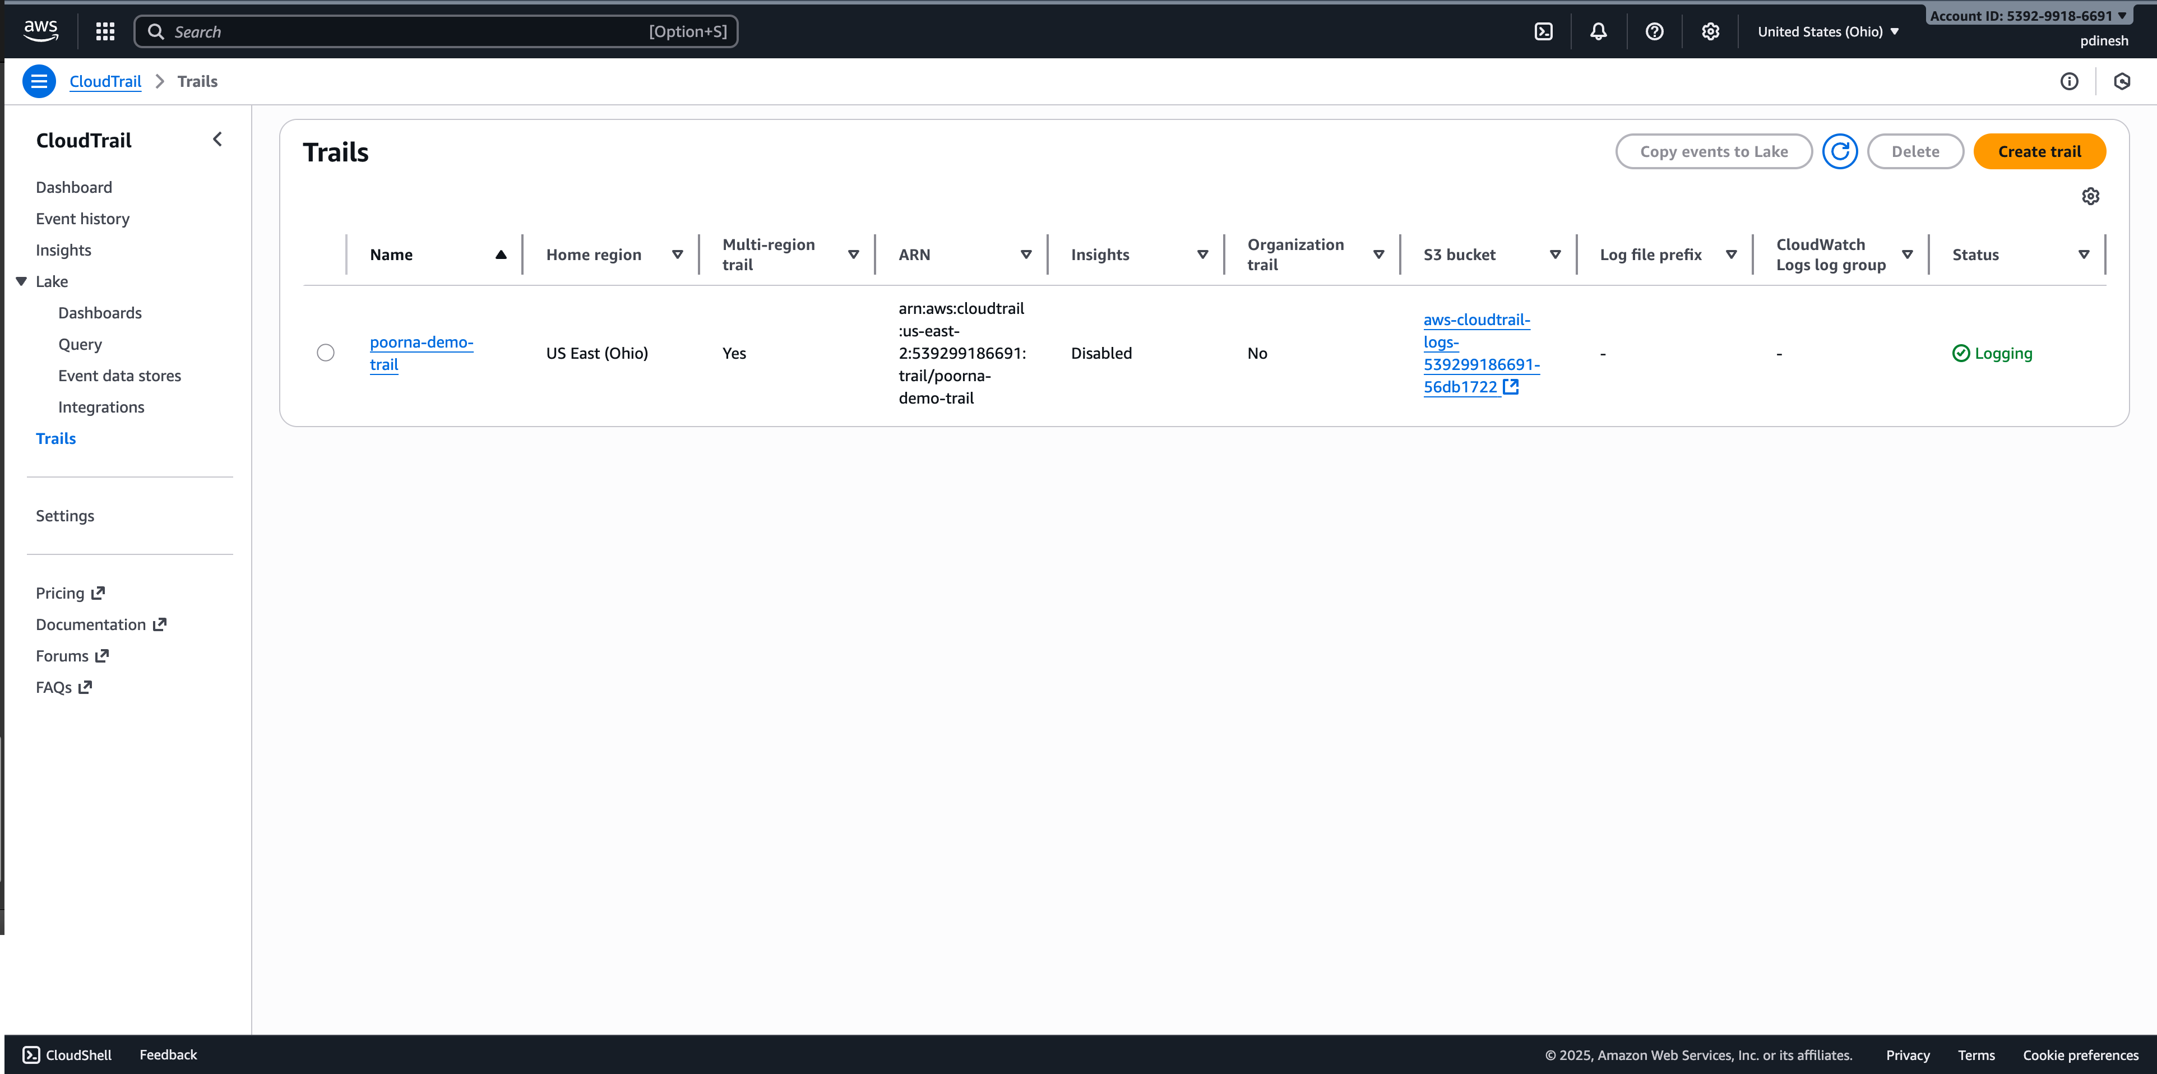

# **Step 4 – Launch EC2 and Create IAM Role**

Created a new IAM Role for EC2 with EC2 as the trusted entity, granting permissions for s3:GetObject and s3:PutObject along with AmazonSSMManagedInstanceCore for Session Manager access, then launched a t2.micro Amazon Linux instance, attached the IAM role, and configured SSH/Session Manager access from my IP address.

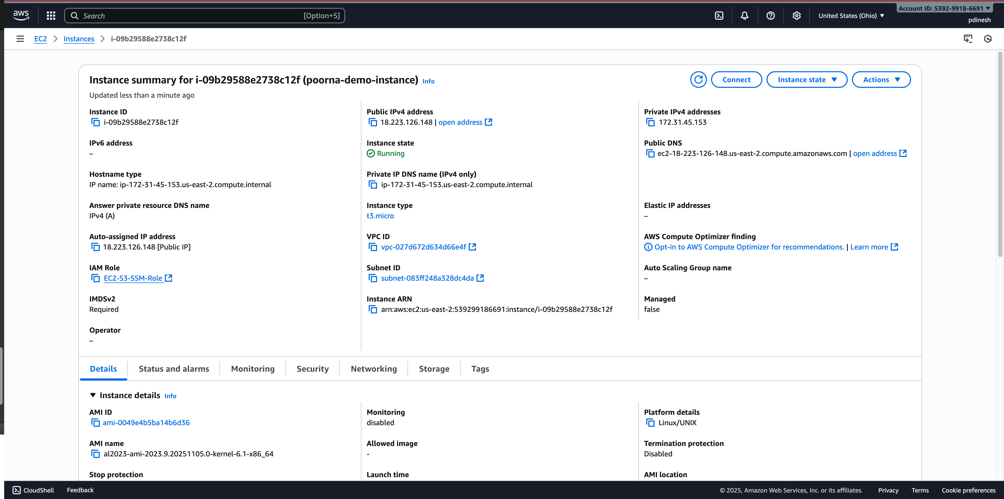

# **Step 5 – Create OS-Level Users and Permissions (on EC2)**

Connected to the EC2 instance, created users **editor** and **reader**, set up **/home/ec2-user/security-demo/secret.txt**, configured permissions for **reader** (read-only) and **editor** (editable), and verified ownership and access with ls -l.

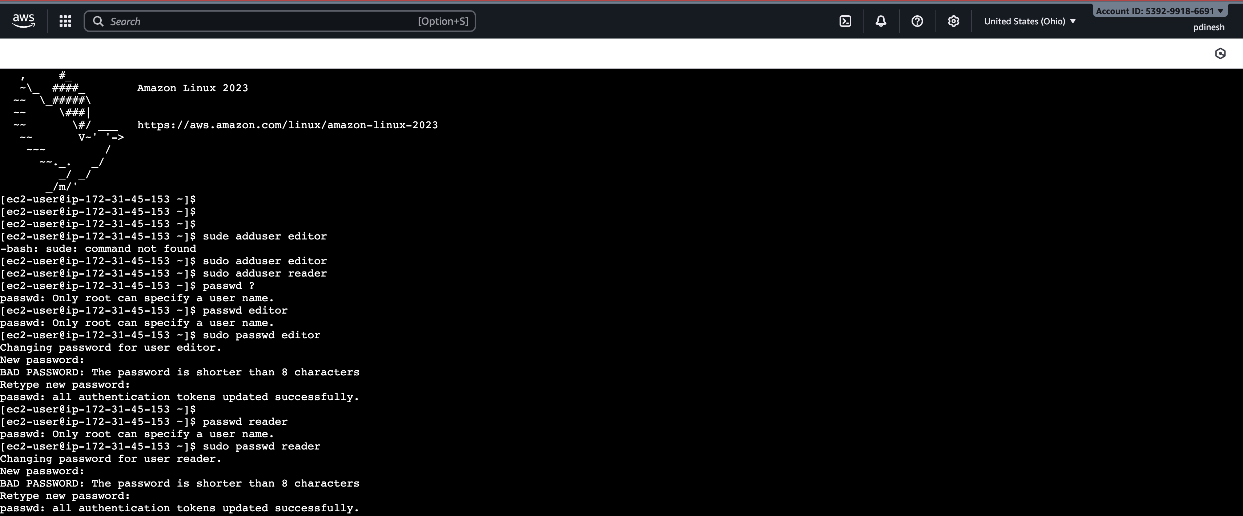

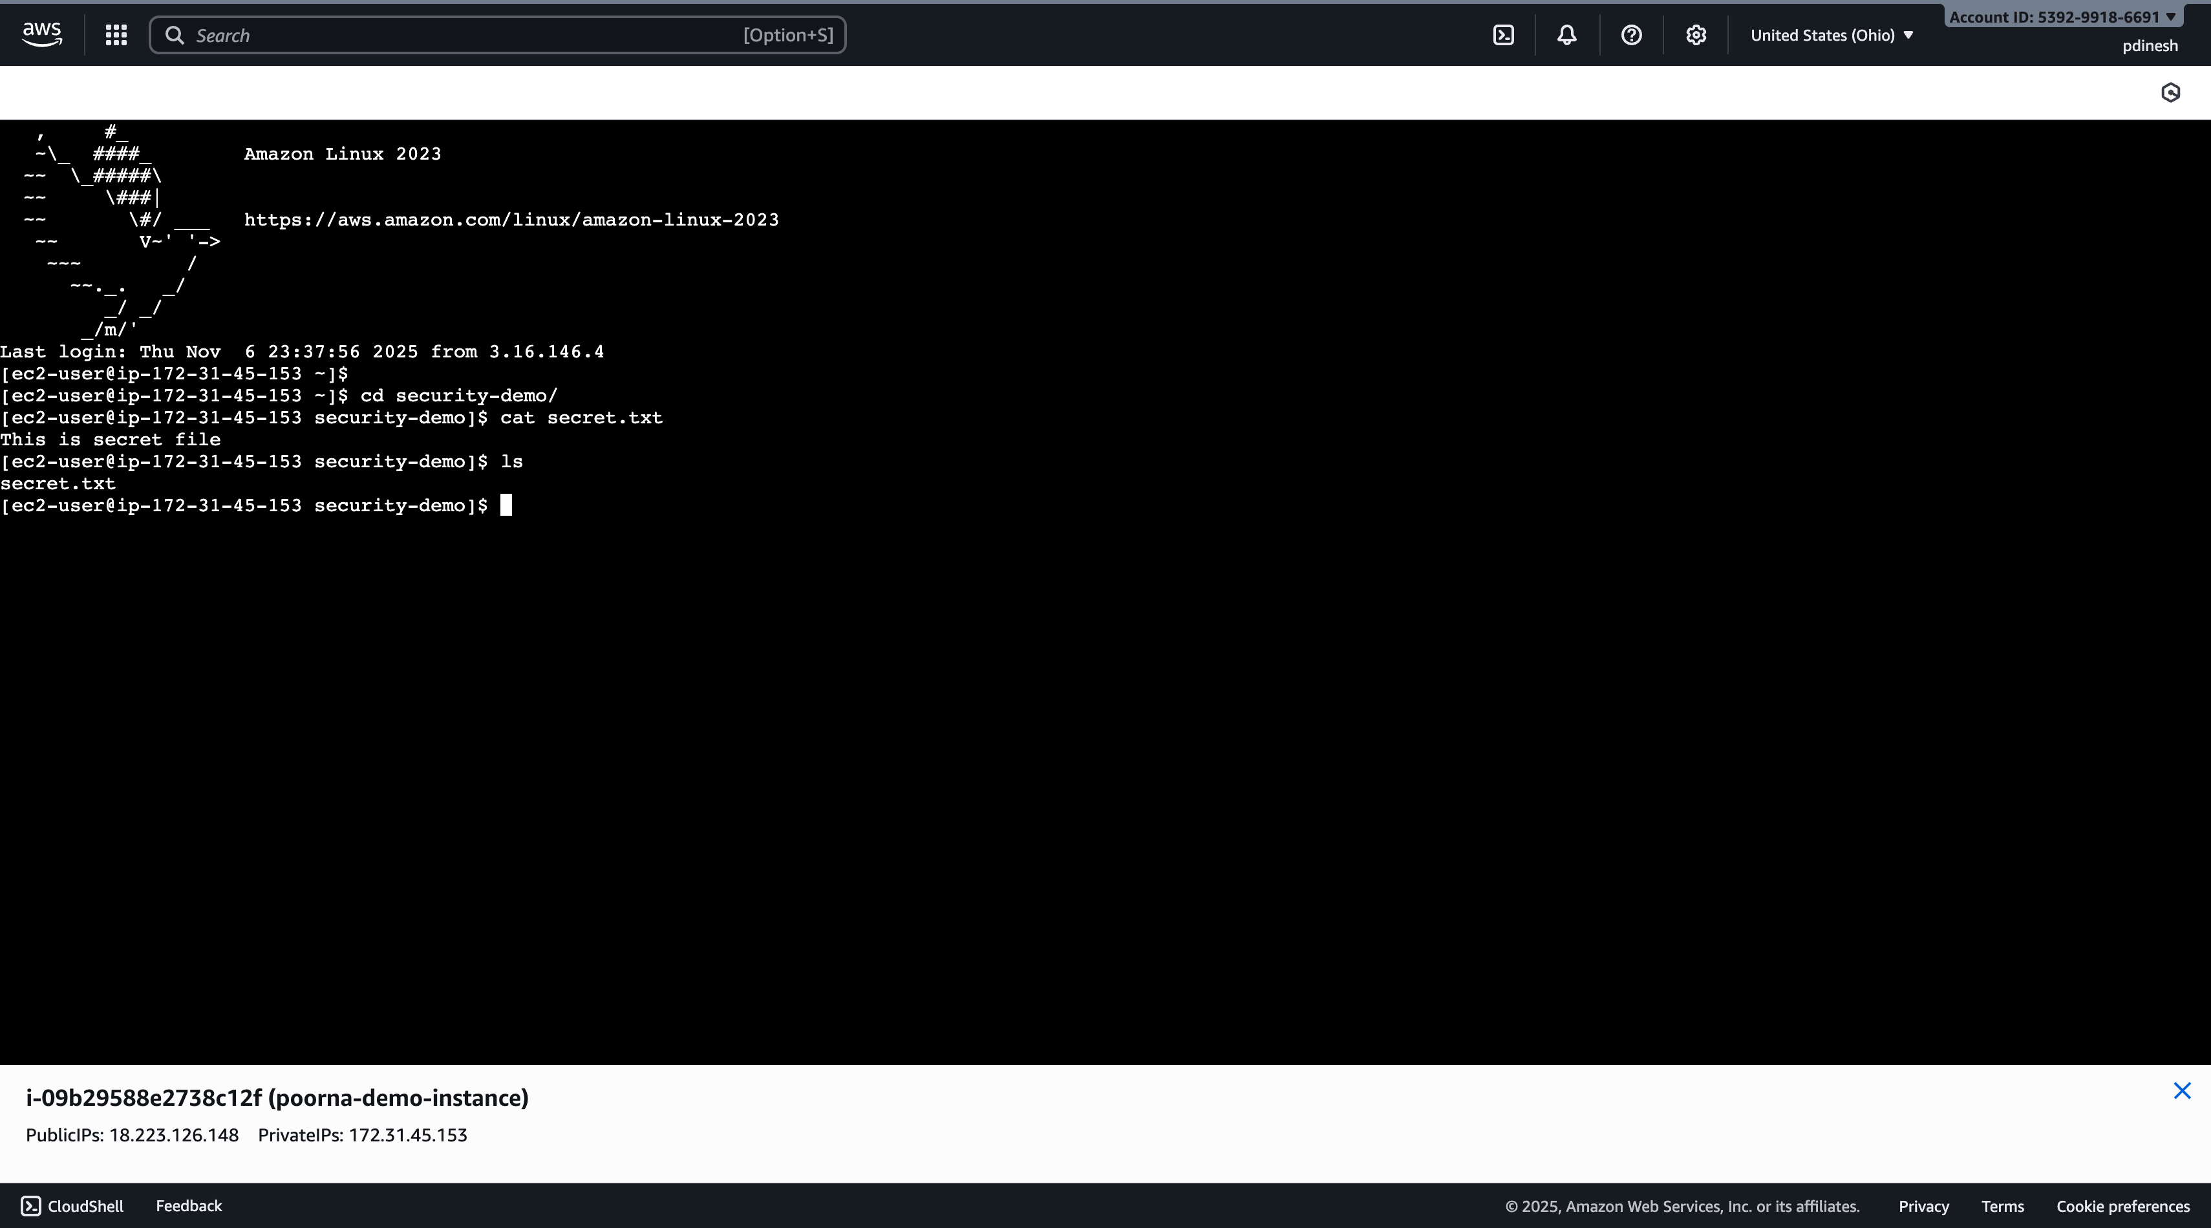

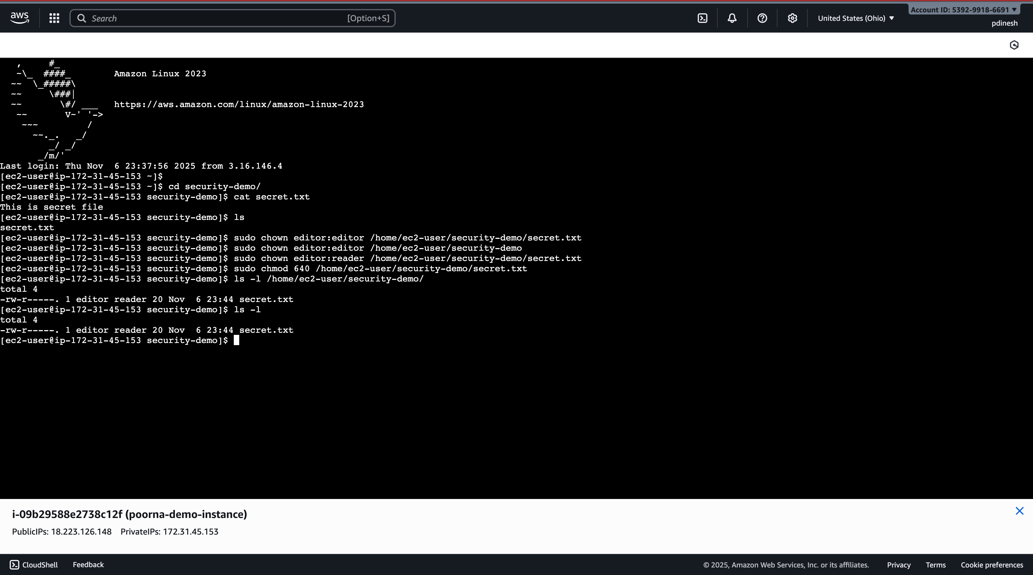

# **Step 6 – Access Behavior**

Logged in as **reader** and confirmed that attempting to append to **secret.txt** failed with a “Permission denied” message. Then logged in as **editor**, successfully edited **secret.txt**, and displayed the updated content using cat, verifying correct permission enforcement.

## Has reader

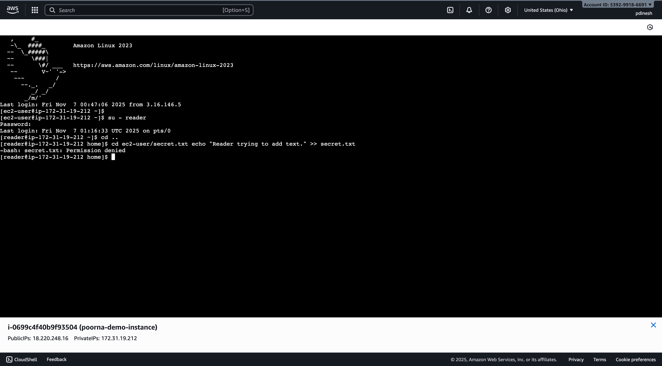

## Has editor

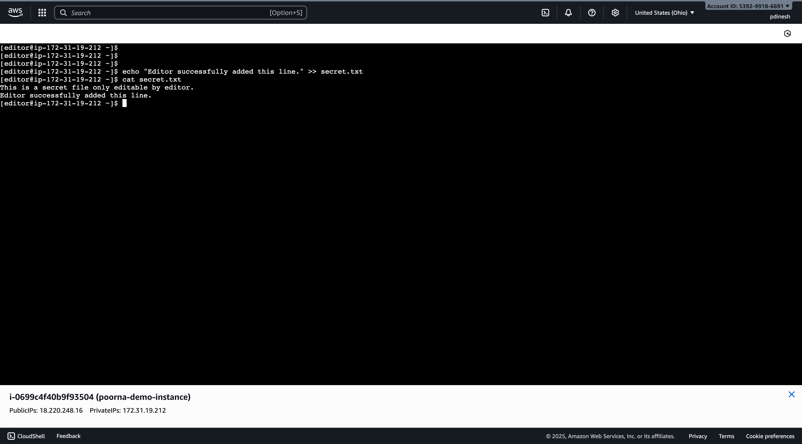

# **Step 7 – Download, Edit, and Re-Upload an S3 File**

Using the AWS CLI on the EC2 instance, downloaded **Test1Upload.txt** from **poorna-security-demo-bucket**, viewed its content with cat, manually edited the file ( added my name), and successfully re-uploaded it to S3 as **edited.txt**, verifying the updated file appears in the S3 console.

## File Before editing

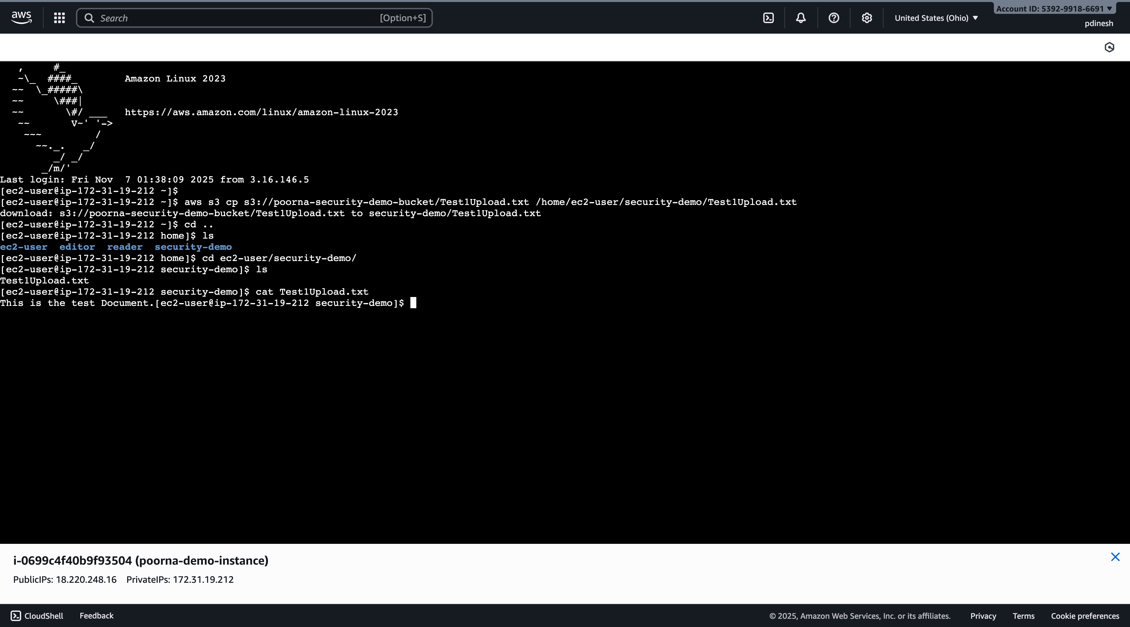

## File After editing

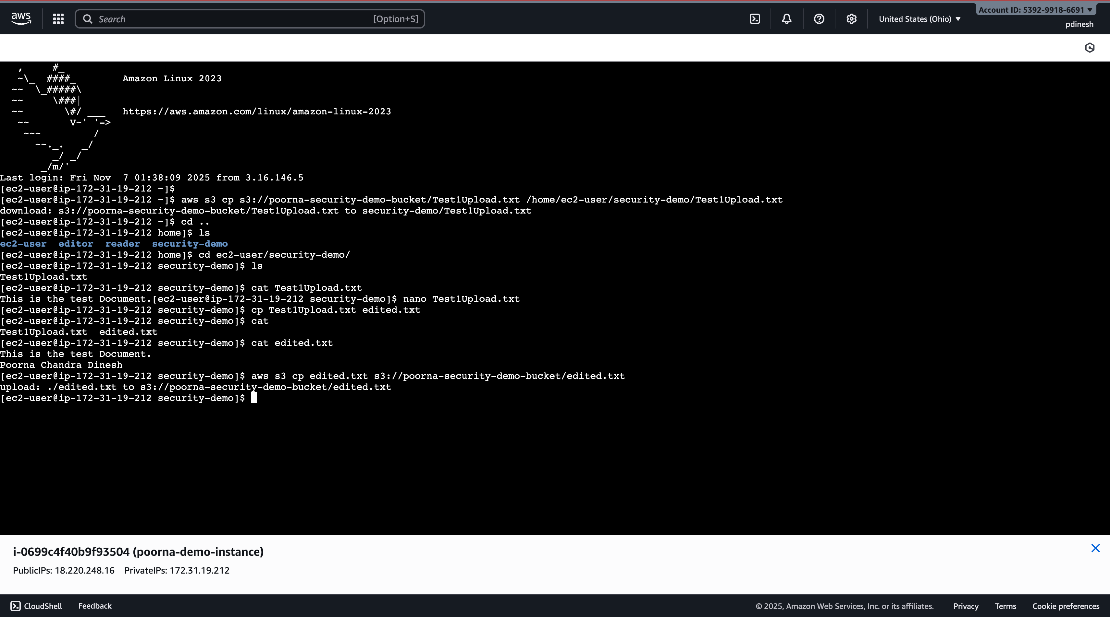

S3 console showing the new or updated file.

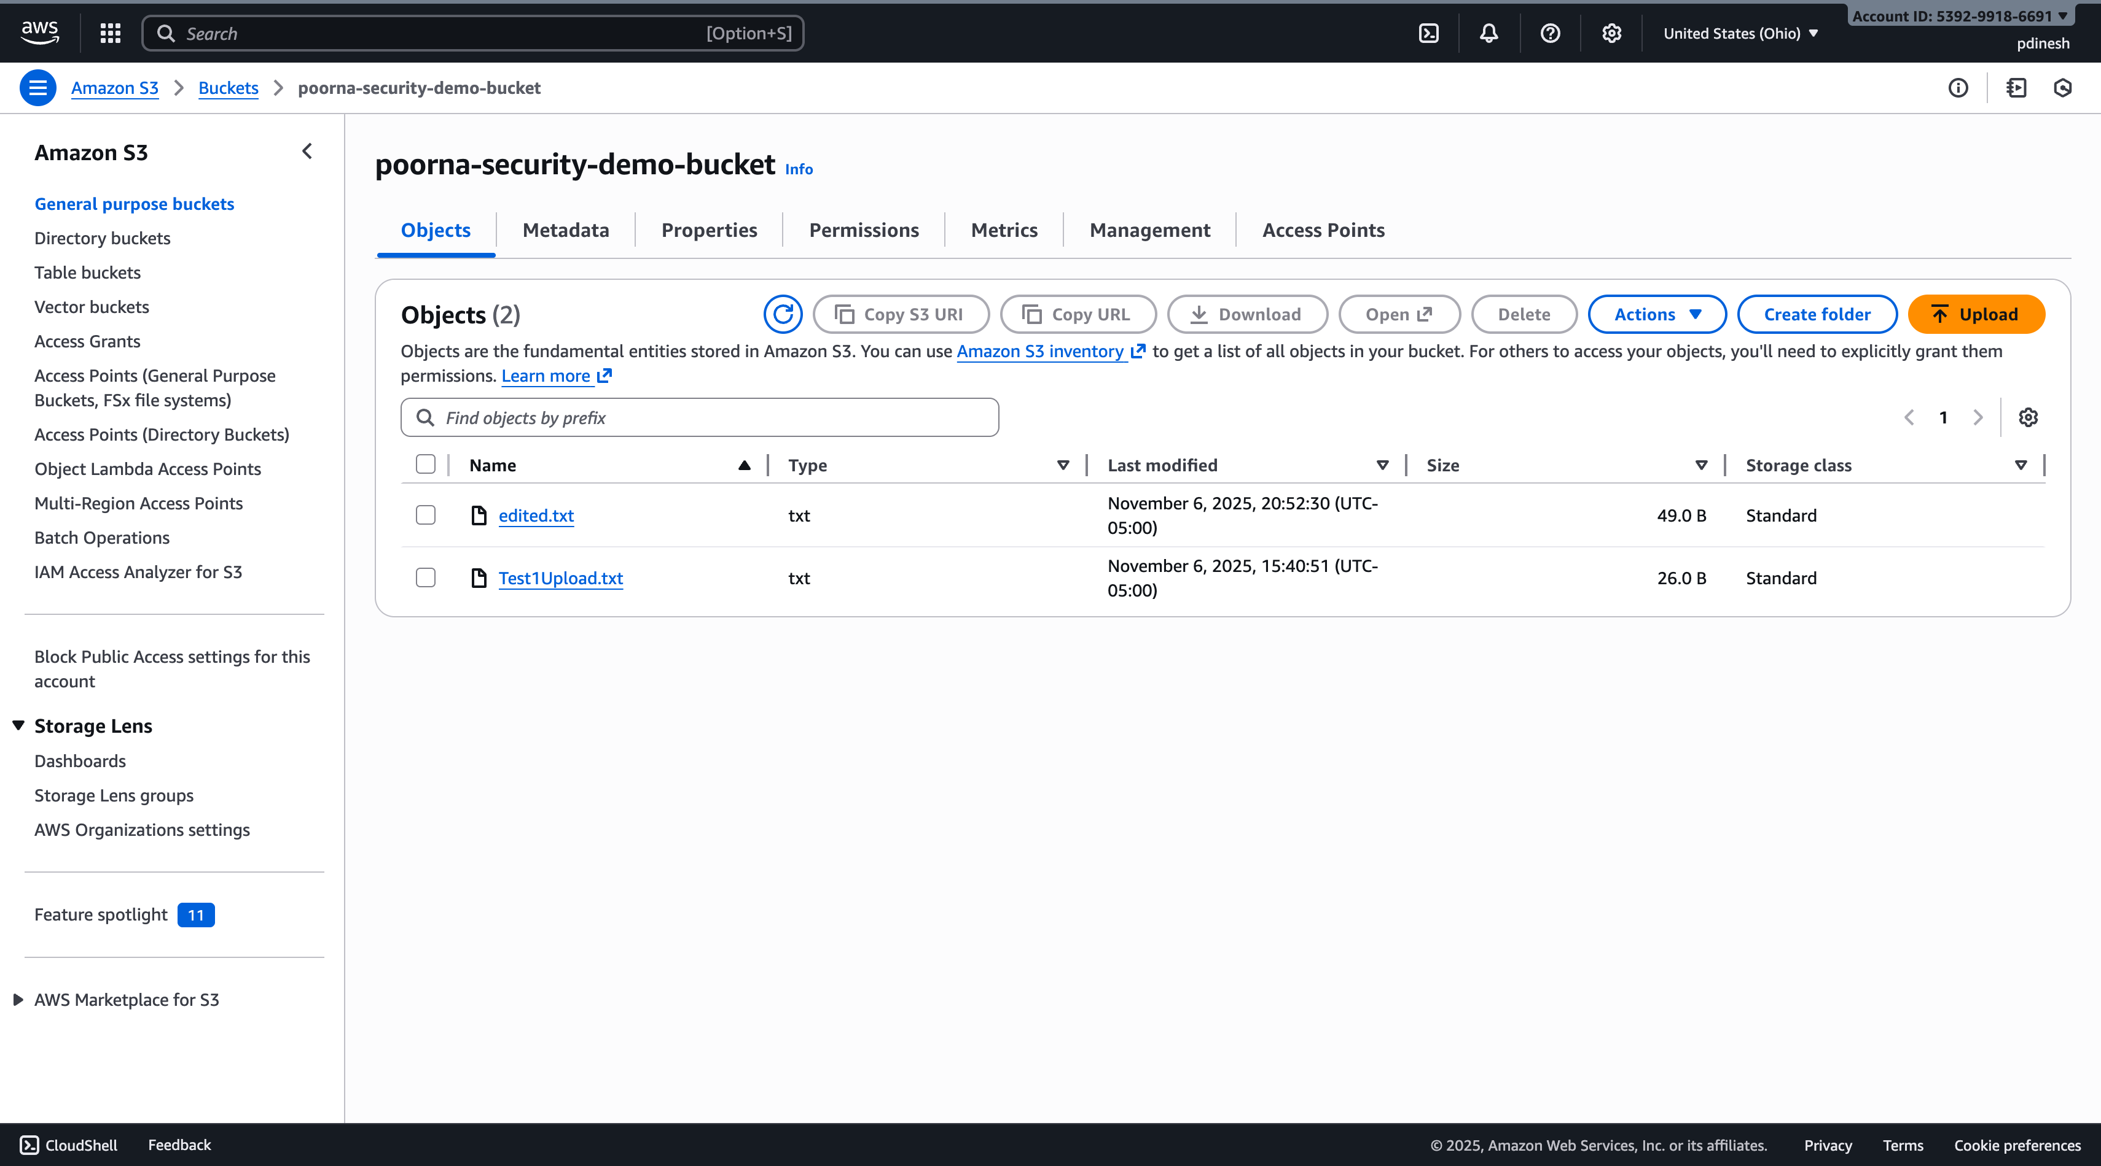

# **Step 8 – Run and Upload an Nmap Scan**

Installed **nmap**, ran a service scan of my EC2 public IP and saved it as var/log/scans/nmap-<timestamp>.log, listed the scans directory and displayed the first 20 lines of the log, uploaded the log to s3://poorna-security-demo-bucket/scans/, and verified the scan file appears in the S3 console.

## Directory listing and log snippet

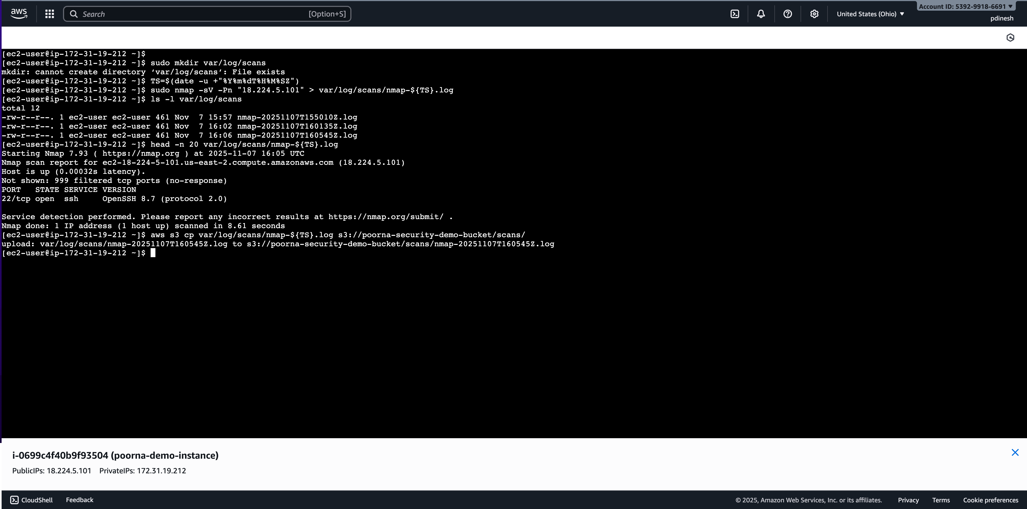

## S3 console

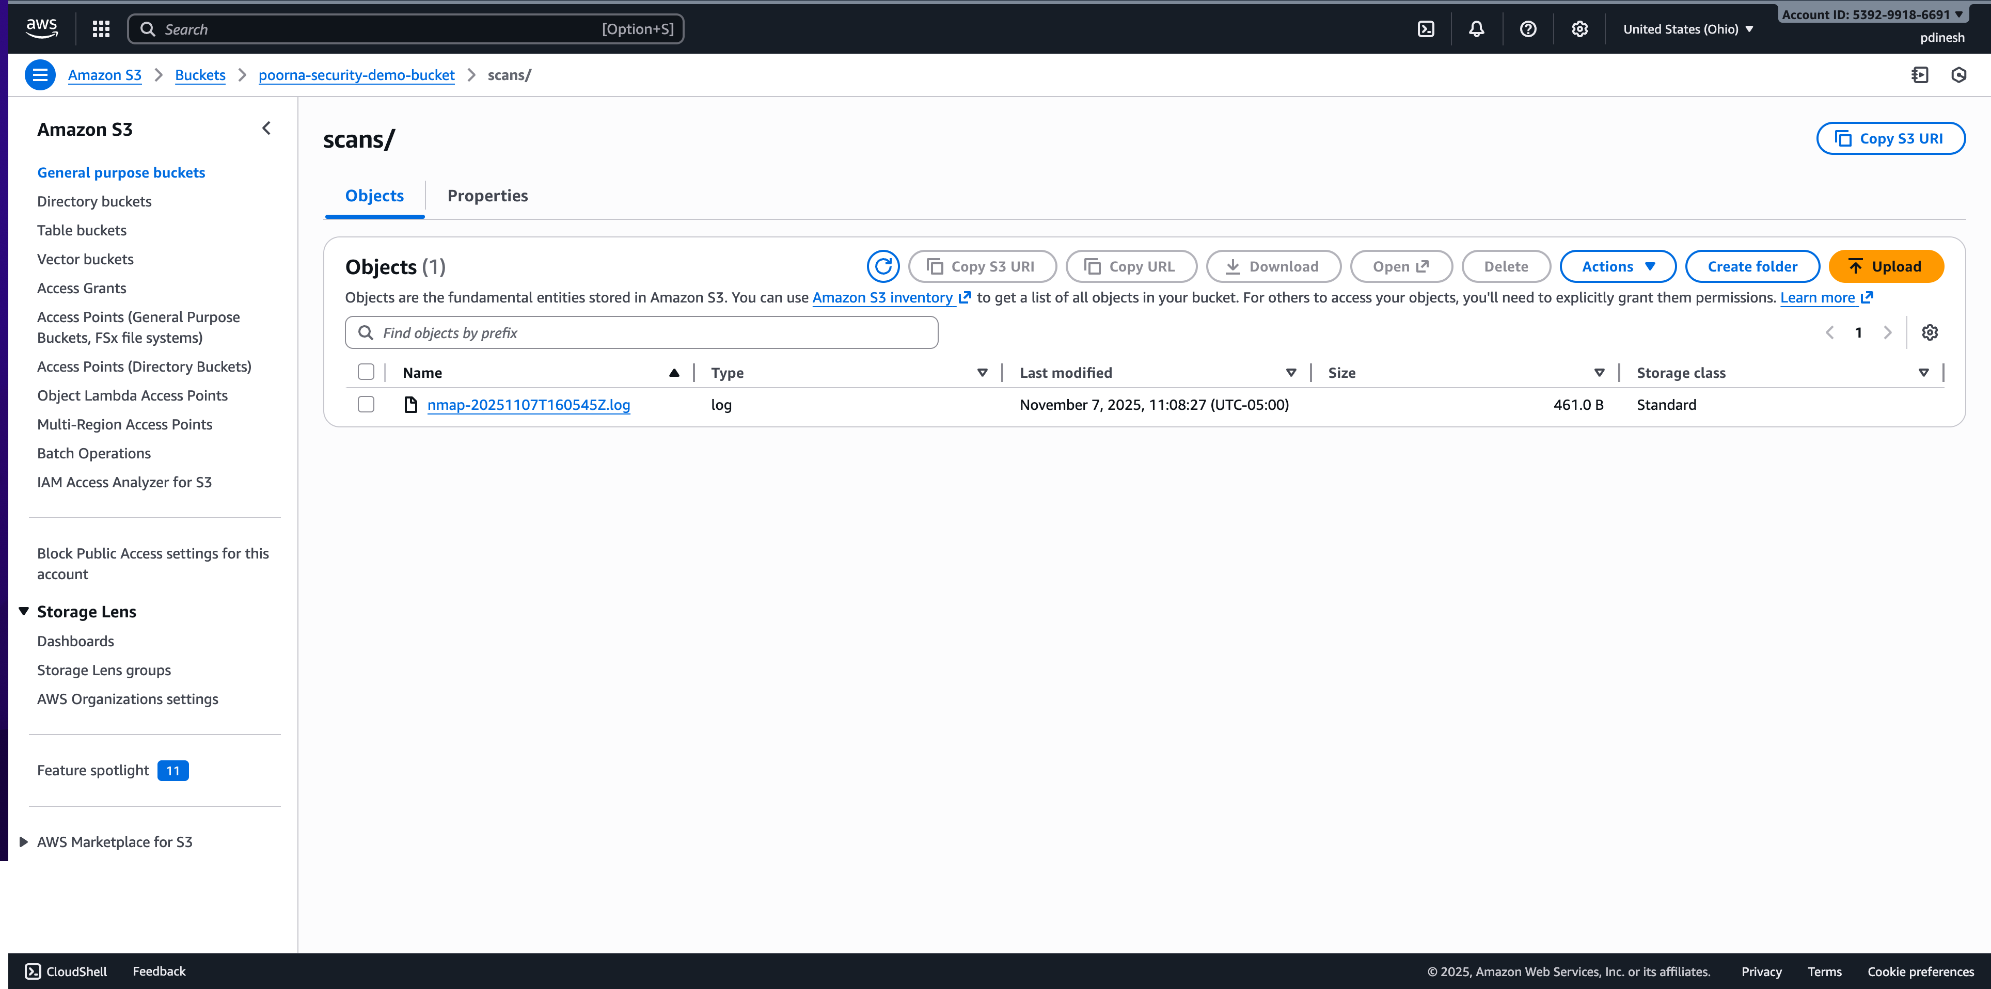

# **Step 9 – View CloudTrail Logs**

Navigated to **CloudTrail → Event history**, filtered by event sources (**iam.amazonaws.com**, **ec2.amazonaws.com**, and **s3.amazonaws.com**) and event names such as **CreateUser**, **RunInstances**, and **PutObject**, verified that the actions were logged with accurate **eventTime** and **userIdentity** details, and captured screenshots of two events confirming they were performed under my account.

Screenshot CreateBucket:  
An event (CreateBucket) visible in the Event history list.  
Include columns for **Event name**, **Event source**, and **Event time**.

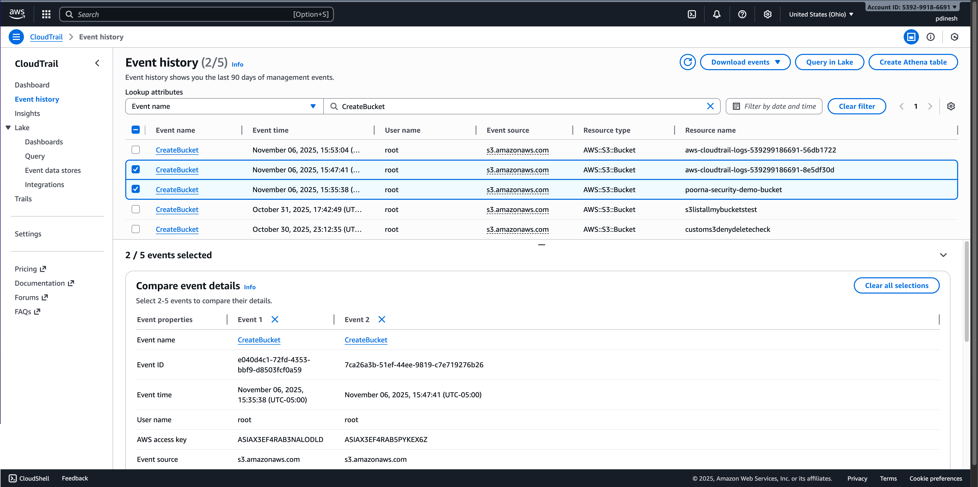

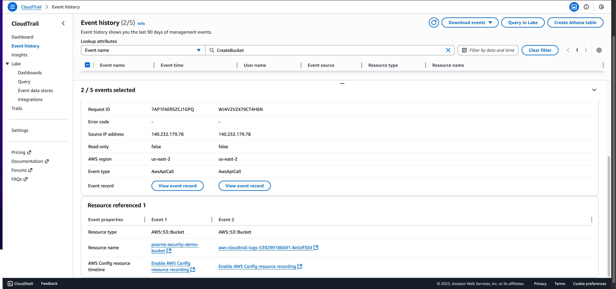

## **Screenshots Event s3.amazonaws.com:**

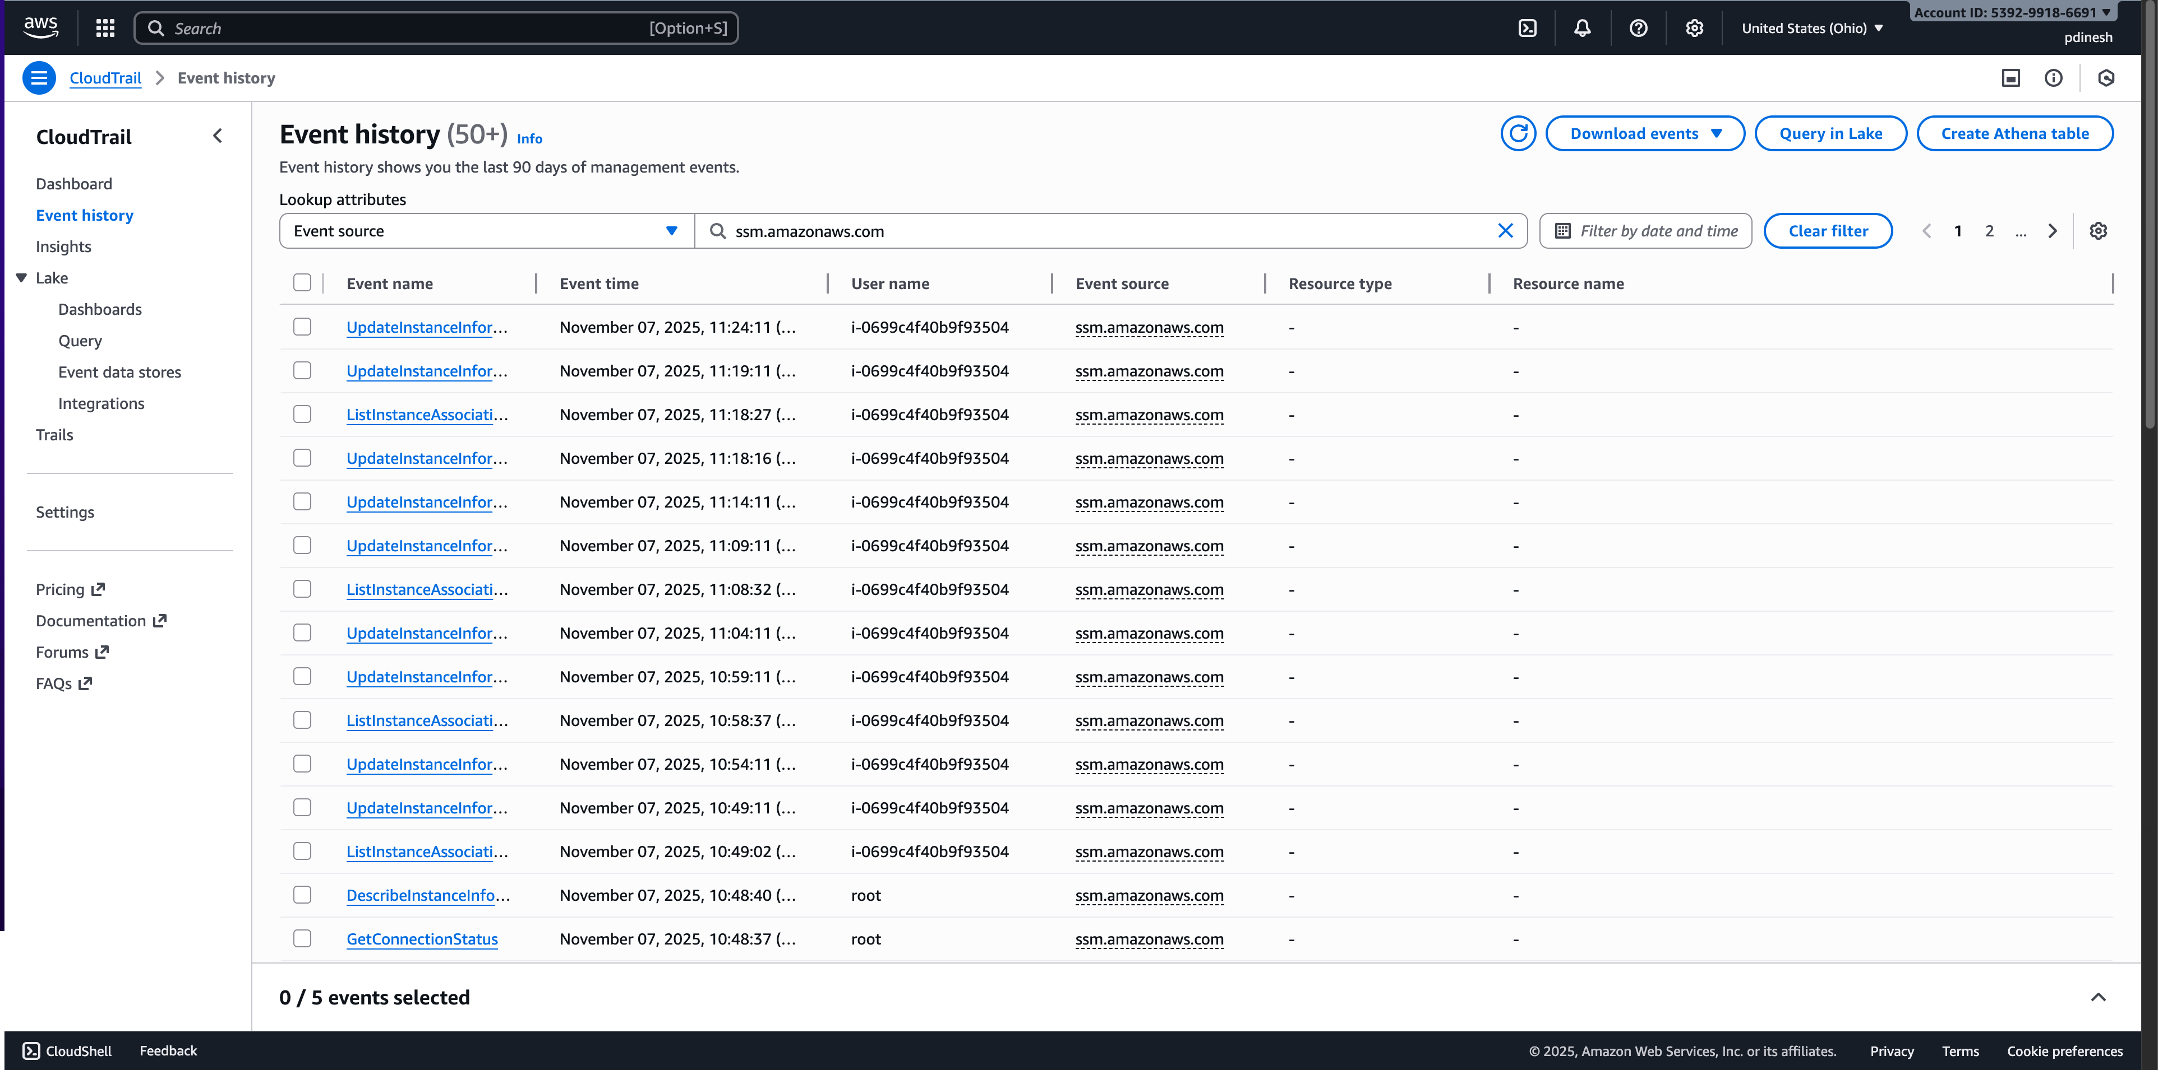

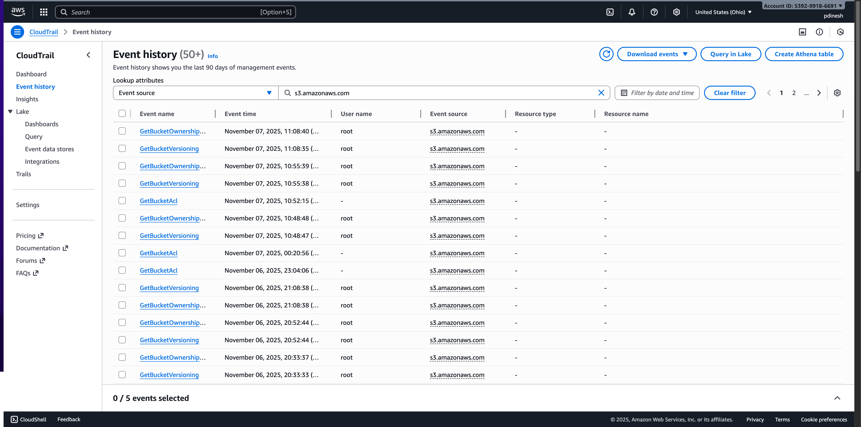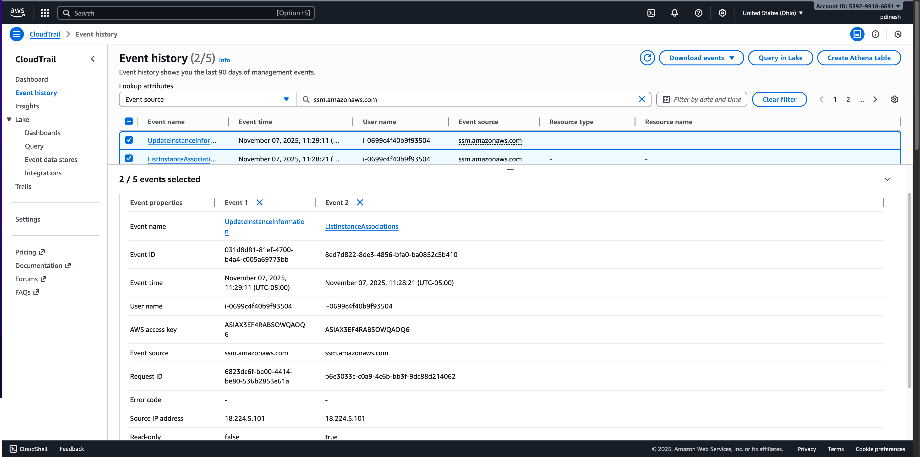

# Step 11 – Cleanup

Successfully terminated the **EC2 instance**, deleted all created **IAM users, groups, and roles**, emptied the **poorna-security-demo-bucket**, and permanently deleted the bucket to complete the cleanup process.

# **Reflection**

What you built and tested**:**  
I created IAM users and roles, launched an EC2 instance, and set up an S3 bucket for storage. I then tested each component to confirm it worked correctly for instance, making sure the EC2 instance could access the S3 bucket using the assigned IAM role, and verifying that different users had the correct permissions.

What CloudTrail showed about your actions:  
CloudTrail recorded every change and operation I performed in my AWS account. It provided details such as the exact time of each action, the type of event, and which user or role executed it. This allowed me to verify that my activity, including creating users, attaching policies, and uploading files, was properly logged.

Why tracking and limiting access are key to secure cloud operations:  
Tracking actions ensures accountability by showing who did what and when, which helps identify unusual or unauthorized behavior quickly. Limiting permissions ensures users and services can only perform the actions they need to, which reduces security risks. Together, these practices strengthen overall cloud safety and prevent accidental or malicious misuse of resources.

**Note:** At the end of the lab, all resources were cleaned up to avoid unnecessary charges and maintain a tidy environment.